PROJECT PLANNING PHASE
Automated Network Request Management in ServiceNow
Field | Details
Date | 13 September 2026
Team ID
Project Name | Automated Network Request Management in ServiceNow

Project Planning Overview
The project planning defines the product backlog, user stories, estimation, sprint schedule, project tracking, velocity and burndown for the Automated Network Request Management solution in ServiceNow. The plan covers the complete implementation lifecycle and is scheduled for final completion on 19 September 2026.

Product Backlog, Sprint Planning, Stories and Estimation
The following backlog converts the required network request functionality into user stories and implementation tasks. Story points represent relative effort and are used to distribute work across the planned sprints.
Sprint | Functional Requirement (Epic) | User Story Number | User Story / Task | Story Points | Priority
Sprint-1 | Requirement Analysis | USN-1 | As a requester, I can submit a standardized network service request with the required information. | 3 | High
Sprint-1 | Requirement Analysis | USN-2 | As an administrator, I can define the required request information and approval requirements. | 2 | High
Sprint-1 | Requirement Analysis | USN-3 | As a project team member, I can document user needs, functional requirements and non-functional requirements. | 3 | High
Sprint-1 | Project Planning | USN-4 | As a project team member, I can create the product backlog, sprint schedule and effort estimates. | 2 | Medium
Sprint-2 | Request Data & Backend | USN-5 | As an administrator, I can configure the Network Request data structure and request fields. | 4 | High
Sprint-2 | Request Data & Backend | USN-6 | As an administrator, I can configure reference, choice and mandatory fields for network requests. | 3 | High
Sprint-2 | Workflow Automation | USN-7 | As an administrator, I can configure approval and fulfilment workflow automation. | 4 | High
Sprint-2 | Workflow Automation | USN-8 | As a fulfilment team member, I can receive an automatically generated fulfilment task. | 2 | High
Sprint-3 | Service Catalog | USN-9 | As a requester, I can access the Network Request catalog item through the Service Portal. | 3 | High
Sprint-3 | Request Form | USN-10 | As a requester, I can enter network request information using configured catalog variables. | 3 | High
Sprint-3 | Requester Information | USN-11 | As a requester, I can select a user and automatically populate related requester information. | 3 | Medium
Sprint-3 | Dynamic Form Behaviour | USN-12 | As a requester, I can see additional fields only when the selected request option requires them. | 3 | High
Sprint-4 | Testing | USN-13 | As a tester, I can validate successful and invalid network request submissions. | 3 | High
Sprint-4 | Workflow Testing | USN-14 | As a tester, I can verify approval, fulfilment task creation, assignment and status updates. | 3 | High
Sprint-4 | Security | USN-15 | As an administrator, I can verify that request and approval information is accessible only to authorized users. | 3 | High
Sprint-4 | Defect Handling | USN-16 | As a project team member, I can record defects, corrections and test results. | 2 | Medium
Sprint-5 | Deployment | USN-17 | As a project team member, I can prepare the completed configuration for final deployment. | 3 | High
Sprint-5 | Documentation | USN-18 | As a project team member, I can prepare configuration evidence and complete project documentation. | 3 | High
Sprint-5 | Demonstration | USN-19 | As a project team member, I can demonstrate the complete network request lifecycle. | 3 | High
Sprint-5 | Final Delivery | USN-20 | As a project team member, I can complete the final presentation and project submission. | 2 | High

Sprint Schedule
Sprint | Total Story Points | Duration | Sprint Start Date | Sprint End Date (Planned) | Story Points Completed | Sprint Release Date (Actual)
Sprint-1 | 10 | 2 Days | 06 Sep 2026 | 07 Sep 2026 | 10 | 07 Sep 2026
Sprint-2 | 13 | 3 Days | 08 Sep 2026 | 10 Sep 2026 | 13 | 10 Sep 2026
Sprint-3 | 12 | 3 Days | 11 Sep 2026 | 13 Sep 2026 | 12 | 13 Sep 2026
Sprint-4 | 11 | 3 Days | 14 Sep 2026 | 16 Sep 2026 | 11 | 16 Sep 2026
Sprint-5 | 11 | 3 Days | 17 Sep 2026 | 19 Sep 2026 | 11 | 19 Sep 2026
Total planned story points: 57. Final project completion and release date: 19 September 2026.

Project Tracker
Sprint | Planned Work | Start Date | End Date | Story Points | Completion
Sprint-1 | Requirements, user stories, backlog and estimation | 06 Sep 2026 | 07 Sep 2026 | 10 | Completed
Sprint-2 | Backend data structure, fields and workflow automation | 08 Sep 2026 | 10 Sep 2026 | 13 | Completed
Sprint-3 | Catalog item, variables, requester information and dynamic UI | 11 Sep 2026 | 13 Sep 2026 | 12 | Completed
Sprint-4 | Testing, workflow validation, defect handling and security checks | 14 Sep 2026 | 16 Sep 2026 | 11 | Completed
Sprint-5 | Deployment preparation, documentation and final demonstration | 17 Sep 2026 | 19 Sep 2026 | 11 | Completed

Velocity
Velocity is the amount of story-point work completed in an iteration. Based on the planned project backlog, 57 story points are distributed across 5 sprints.
Average Velocity = Total Story Points / Number of Sprints = 57 / 5 = 11.4 story points per sprint

Burndown Chart
The burndown chart shows the planned reduction of remaining work across the sprint schedule. The project reaches zero remaining story points on the final completion date.
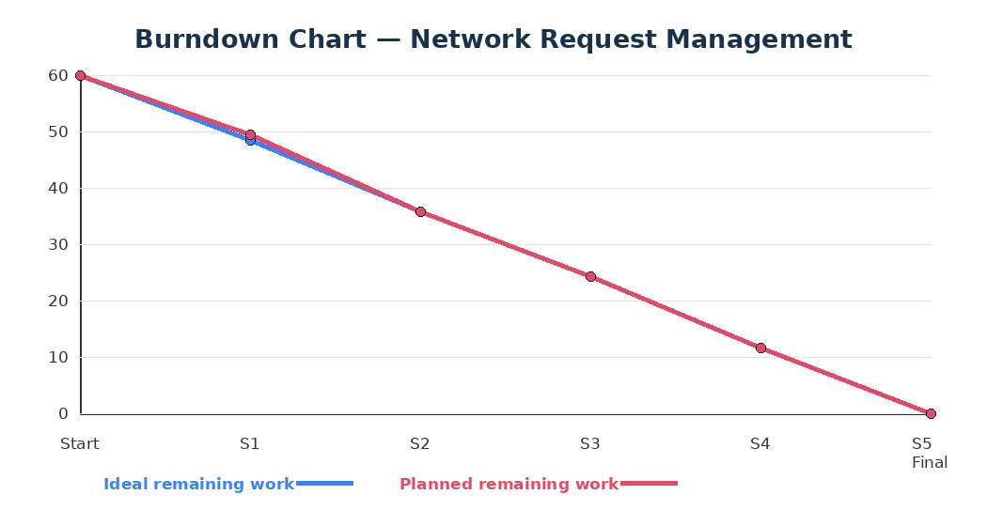

Project Completion
The planned project work is completed by the end of Sprint-5 on 19 September 2026. The final deliverable includes the configured ServiceNow network request solution, validated request lifecycle, testing and security evidence, documentation and final demonstration.

